

**UNITED INTERNATIONAL UNIVERSITY**

LAB REPORT- 07

Course Name: Control System Laboratory

Course Code: EEE 402/ EEE 4110 (A)

**Submitted To;**

RAHMAN, KALED MASUKUR

PROFESSOR

UIU

**Submitted By;**

Name: Monisha Roy

ID: 021-182-031

Name: Joyanta Debnath

ID: 021-182-032

Date of Submission:

**Experiment Name:** Design a LEAD-LAG COMPENSATOR using Root Locus Method and SISO design tool.

**Objective:**

* Understanding Lead-lag Controller.
* Familiarity with Root Locus Method.
* SISO Design Tool Proficiency.
* Plant Modeling and Transfer Functions.
* Engineering Decision-Making Skills.
* Physical realization of Lead-lag Compensation.

**Design Requirement:** Given the transfer function,  and H(s)=1. The Lead-lag controller should meet the following criteria;

1. Should operate at 20% %OS.
2. A twofold reduction in settling time.
3. Tenfold improvement in steady-state error for a step input.

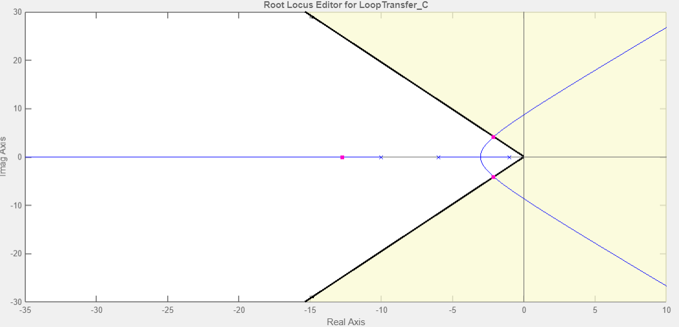**Uncompensated Condition:** Plant and compensator= and dominant poles at, -2.13+ 4.15

|  |  |  |  |  |  |  |  |  |  |
| --- | --- | --- | --- | --- | --- | --- | --- | --- | --- |
| K | ζ | ωn | %OS | Ts | Tp | Kp | e(∞) | Other poles | Zeros |
| 217.5 | 0.456 | 4.67 | 18.5 | 1.86 | 0.845 | 3.625 | 0.216 | -12.7 | NA |

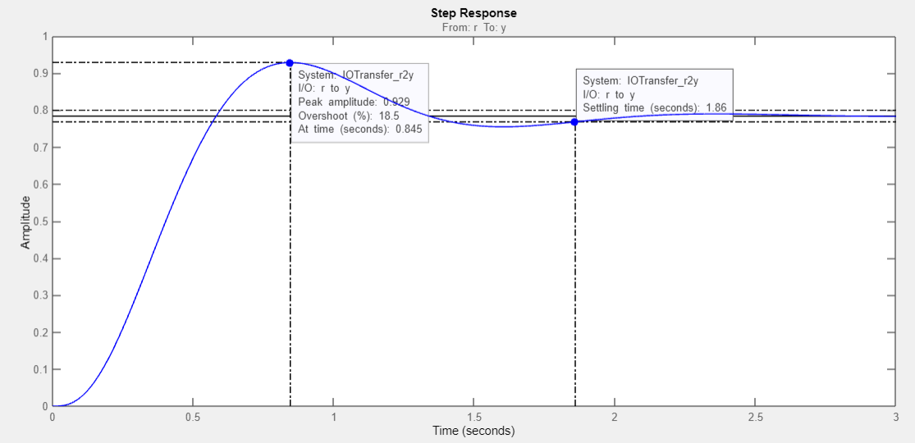

**Lead Compensated condition:** Plant and compensator=  and dominant poles at, -4.26 + j8.31

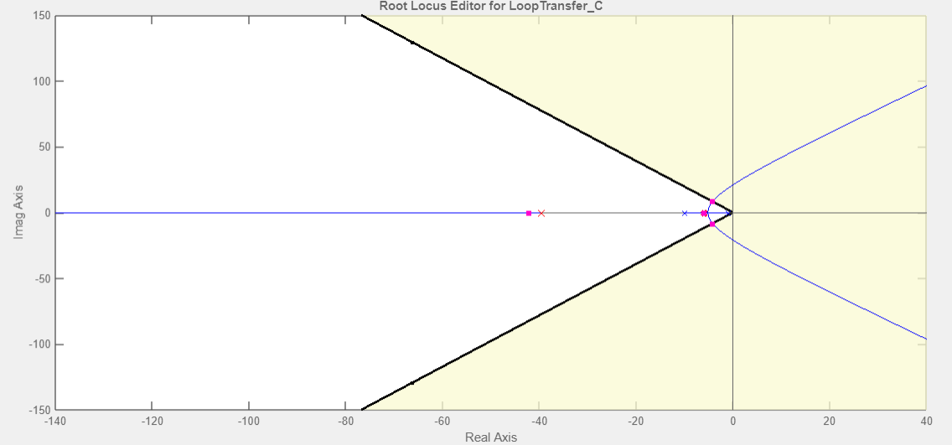

|  |  |  |  |  |  |  |  |  |  |
| --- | --- | --- | --- | --- | --- | --- | --- | --- | --- |
| K | ζ | ωn | %OS | Ts | Tp | Kp | e(∞) | Other poles | Zeros |
| 3270 | 0.456 | 9.34 | 19.4 | 0.915 | 0.4 | 8.26 | 0.107 | -6,-42 | -6 |

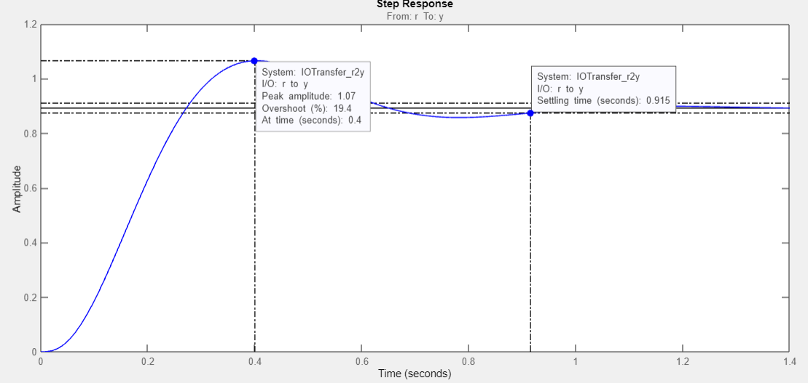

**Lead-lag Compensated condition:** Plant and compensator= $\frac{3270(s+6)(s+0.01)}{(s^{3}+17s^{2}+76s+60)(s+39.56)(s+0.055)}$

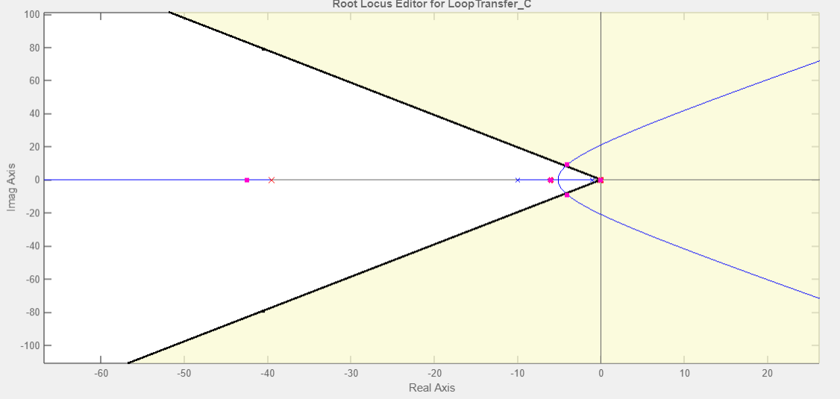

|  |  |  |  |  |  |  |  |  |  |
| --- | --- | --- | --- | --- | --- | --- | --- | --- | --- |
| K | ζ | ωn | %OS | Ts | Tp | Kp | e(∞) | Other poles | Zeros |
|  |  |  | 15.8 | 24.9 | 0.366 | 45.3 | 0.0216 |  | -6,-0.055 |

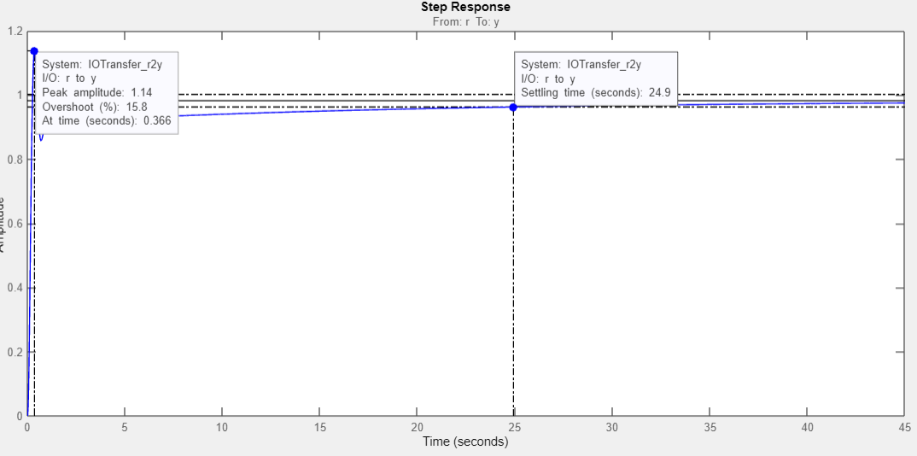

**Lead-lag Controller:**

**Lead-lag** **Gp**

+

-

**Discussion:**

* **%OS change in Lead-lag**: Here we can see maximum deviation of the system's response from its steady-state values. Increasing Kp tends to increase the percent overshoot and minimizes Ts in Lead compensation. Moreover, in Lead-lag compensation following the third pole domination, it is hard to maintain required %OS, thus vivid increase in Ts has been noticed. In terms of pole-zero cancellation, we have to put the zero nearer to the pole to cancel out the effect of pole located near origin.
* **Acceptability**: Weather or not this Lead-lag compensator is accepted, is highly dependent on the application of the controller. Although, Ts is much higher in Lead-lag compensation but in terms of response, Lag compensation is faster than Lead.
* **Trial and Error**: As we failed to maintain required %OS, in terms of pole-zero cancellation, we have to amend the zero and pole of Lag compensator which is located near origin, so that we can find precise values to complement the given criteria.

**Physical realization of Lead-lag:**

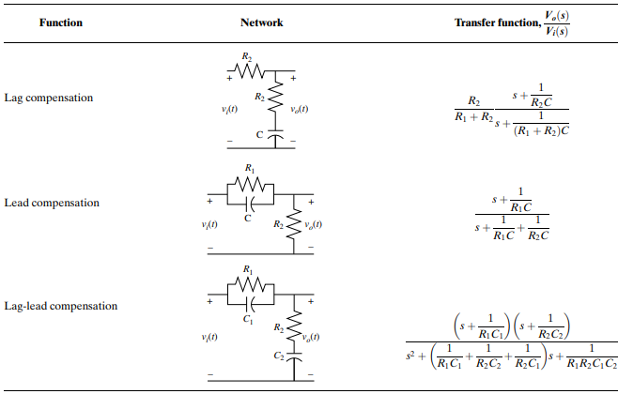

Here, Lead Compensator= $\frac{3270(s+6)}{(s+39.56)}$; so, $\frac{1}{R_{1}C}=6$ and, $\frac{1}{R_{1}C}+\frac{1}{R_{2}C}=39.56$

Let, C= 1µF ; $R_{1}$ = 166.67KΩ and, $R_{2}$ = 29.797KΩ

Now, Lag Compensator= $\frac{(s+0.01)}{(s+0.055)}$; so, $\frac{1}{R_{2}C}$ = 0.01 and, $\frac{1}{{(R}_{1}+R_{2})C}$ = 0.055

Let, C=1µF ; ${(R}_{1}+R_{2})$ = 18.18MΩ